Business Requirements Document (BRD)
  - Customer Level Settlement Enhancement
  - Verification Initiation.
  - June 2024- COL-67

Date | Version Number | Document Changes
19-06-2024 | 1 | Customer Level Settlement Enhancement

Approval

Role | Name | Title | Signature | Date
Project Sponsor | ABHFL
Business Owner | Ashish Chugh
Project Manager | Abhijat Dave
BRD Created by | Pravin Mishra
Development Lead | Credit Nirvana

1 Introduction
Currently, the settlement module operates at the loan level. However, business also require the settlement process to the customer level.
2. Objectives:
To enhance the settlement functionality to operate at the customer level
3. Scope:
The scope of this enhancement includes:

- Introducing a customer level search option.
- Modifying existing screens and introducing new screens for customer level settlement.
- Providing detailed loan information under customer level settlement.
- Incorporating fields for additional charges and remarks during settlement initiation.
- Implementing approval workflows with transparency on approval statuses.
- Generating settlement letters and trigger them via SMS, email, and download options.
- Modifying the receipting process to align with customer level settlements.
4. Business Requirements:
Customer Level Search Option:

- Add a search functionality at the Allocation Status screen to search for customers.

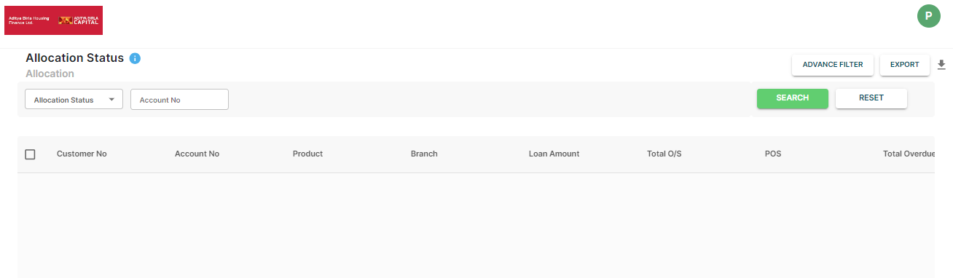

Tab Renaming and Addition:

- Rename the current tab to "Loan Level Settlement".
- Introduce a new tab named "Customer Level Settlement".

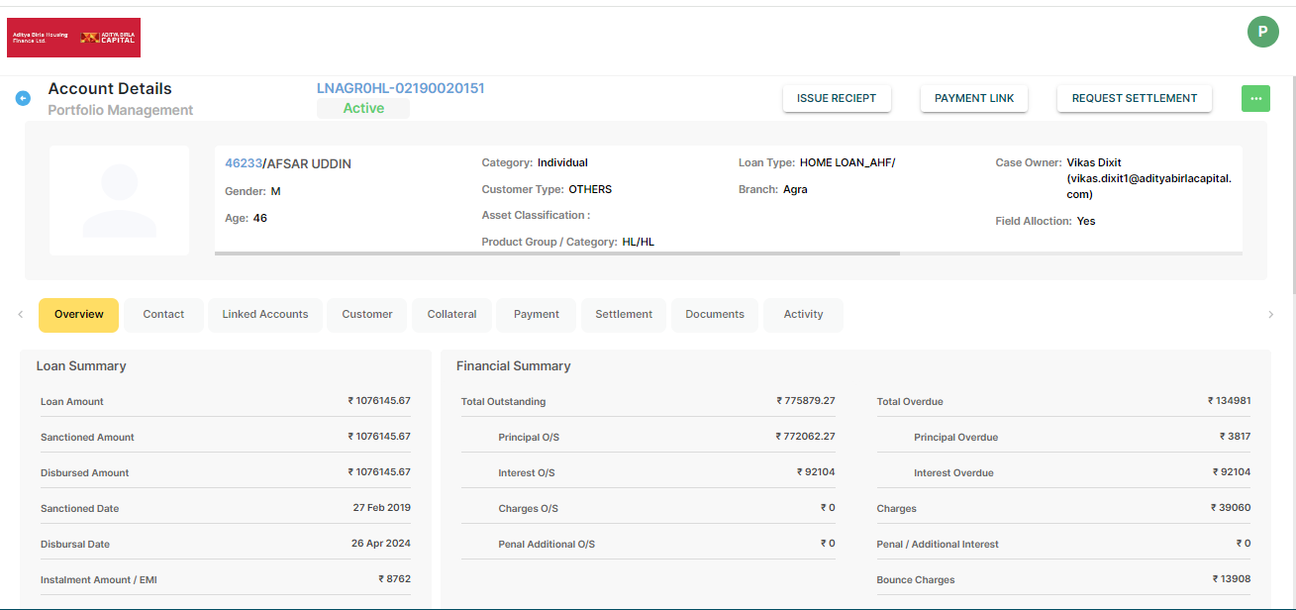

Customer Level Settlement Screen:

- Upon selecting customer level settlement, open a new window displaying:

Customer details.
Customer
Category
Type
Gender
Total O/S
Total Overdue
Contact No
Email
Address
Principal overdue
interest overdue
principal outstanding
charges overdue

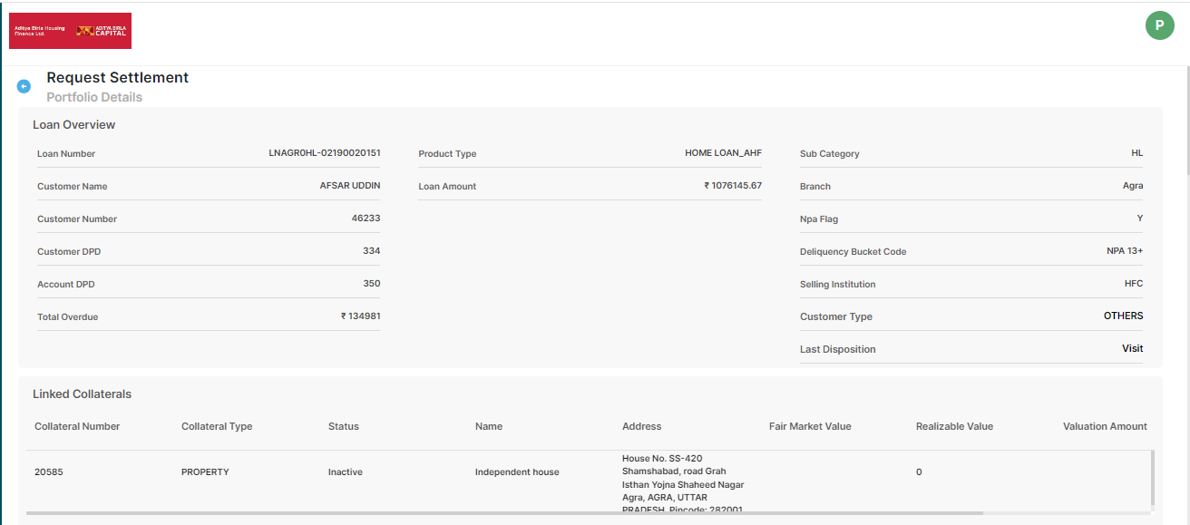

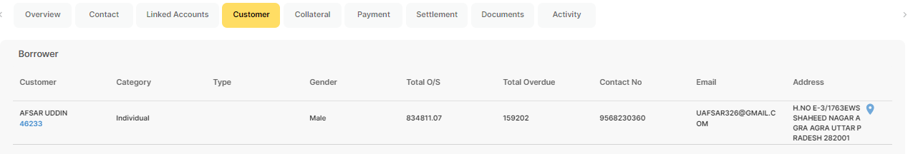

All loans associated with the customer:
- Principal overdue, interest overdue, principal outstanding, and charges overdue for each loan reflect in front end.
Additional Fields:
- Text input fields required, Other Charges: for the Amount field and Remarks: Description of charges.

Settlement Amount Breakup | LOAN 1 | LOAN 2 | LOAN 3 | Total Customer level | Negotiated Amount | Waiver Amount | Recovery% | Waiver%
principal outstanding | 100 | 150 | 20 | 270
interest overdue | 80 | 70 | 60 | 210
Principal overdue | 300 | 200 | 100 | 600
charges overdue | 10 | 20 | 30 | 60
Other Charges | 15 | Remarks | FC charges
Total O/S |  |  |  | 1155

Initiate Settlement
- Allow users to initiate settlement for approval. Include an option to upload an Excel, PDF and Word file for necessary documentation.
- Mandatory to upload the Settlement request letter from customer
- The settlement initiation rule configured only customer level.

Approval Details
- Display approval details (Level 1, Level 2, Level 3) within the application interface for transparency.
Settlement Letter Generation
- Upon final approval, generate a settlement letter using a template provided by the collection team.
- Manual option required to trigger settlement letters to the customer's registered mobile number, SMS, and email.
- Provide an option to download the settlement letter from the application.
Receipting Process:
- No receipt flow from CN to LMS for settlement cases.
- Collection team not issues any receipts for the settlement cases, its done outside the CN application.
- CN provides the settlement payment report to CPU team with approval details (Level 1, Level 2, Level 3)
- Operations & CPU team reconcile the payment and perform manual receipting based on the proportion of POS.
- Operation team tags settlement flagging in LMS post receiving the first tranche against settlement.
- Risk team authenticates the settlement flagging in LMS.

Important point of this requirement:
- All settlement letters are to be issued with the name of the applicant and co-applicants, for this point collection team will provide the template.
- required text field to enter the CIBIL score manually by collection team , this option require at the time of settlement initiation .
- We need to send back and assign buttons during the approval screen. We also need remarks filed.
- Required upload option at all approval screens where the approval person can upload the mail, PDF, and Excel document.
- The SOA can be downloaded from the A3S LMS.
- For the settlement cases, all payment will be updated out of CN only. And post payment updation, payment status will be sent to CN by Daily data file.
- There must be a mandatory option to upload Settlement request taken from customer while generating a settlement request. System must not allow user to submit any request with this letter.

